PRACTICAL NO. 5

Key Exchange using Diffie-Hellman: Implement the Diffie-Hellman key exchange algorithm to securely exchange keys between two entities over an insecure network.MD5

Server Code:
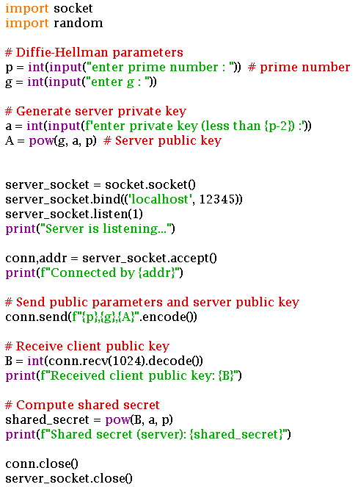

Client Code:
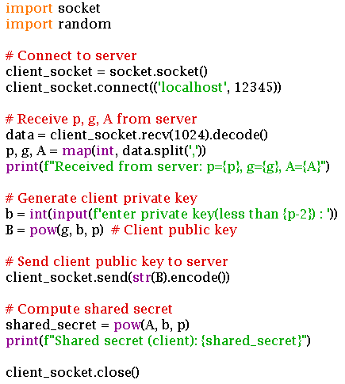
Server Output:
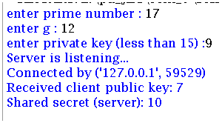
Client Output:
